**Restoration of the Colorado River Delta: Assessing the impacts of the Minute 319 environmental pulse flow**

**Overview**

The Colorado River is one of the most overdrawn rivers in the world, with water usage now officially exceeding water availability (Hanak *et al.* 2016, PPIC report). This demand for water has led to a situation in which little or no fresh water reaches the Colorado River Delta in any given year. The loss of freshwater flows to the Colorado River Delta has greatly transformed the physical and biological processes that previously sustained the Delta. In recent years, scientists and policy makers have explored the possibility of reinstating freshwater flows into the Delta, ultimately culminating in an environmental “pulse flow” of water to the Delta as a provision of the 2012 Minute 319 agreement between the United States and Mexico. This binational agreement allocated Colorado River water explicitly for the purpose of environmental flows and has been lauded as a landmark agreement for the restoration of arid river deltas worldwide (Kendy *et al.* 2017).

In this paper, I will discuss the history of the Colorado River Delta and its restoration, beginning with a description of the Delta prior to the construction of dams along the Colorado River in the 20th century. I will then discuss conditions in the present-day Delta, including an overview of why the Colorado River Delta is a priority for ecological restoration. Next, I will briefly cover the terms of the Minute 319 agreement and the stated objectives of the associated environmental pulse flow. I will then describe the effects of this pulse flow and assess the extent to which stated objectives were met, concluding with a series of recommendations for future environmental flows to the Colorado River Delta.

**Colorado River Delta pre-1930**

Prior to construction of the Hoover Dam, the Colorado River’s drainage basin—an area of over 600,000 km2—emptied into the Colorado River Delta and the Gulf of California. Peak annual flows into the Delta were consistently above 2,000 m3/s, and reached 5,000 m3/s at least three times between 1905 and 1936 (Mueller *et al.* 2017, Figure 1). Transport of an estimated 160 million tons of suspended sediment per year sustained depositional processes involved in river delta formation, which counteracted the erosional processes associated with the Delta’s extremely high tides (Van Andel 1964). Flows typically peaked in the late spring between April and June, and water flowed continuously throughout the year, with the lowest flows of around 100 m3/s typically occurring in December and January. Estimates of the Delta’s size prior to upstream dam construction place its extent around 8,000 km2, slightly larger than the state of Delaware.

First-hand accounts of the Colorado River Delta prior to water diversion are somewhat limited, with perhaps the best-known record coming from conservationist Aldo Leopold’s 1922 journey by canoe in his memoir *A Sand County Almanac* (Leopold 1949). Of his travels within the Delta, Leopold describes a “milk-and-honey wilderness” of green lagoons and canopy forests of mesquite and cottonwood, with abundant game including quail, geese, and ducks. Perhaps the strongest empirical evidence of the Delta’s former conditions can be seen in excavations of bivalve remains from the estuary area around Montague Island in the Delta. Dietl and Smith (2017) compared densities of living bivalves and their depositional patterns to past deposits of bivalves and estimated that past densities of the endemic clam *Mullinia modesta* reached upwards of 50 individuals/m2. For comparison, current *M. modesta* densities are estimated to be less than 3 individuals/m2.

**Colorado River Delta: 1930 and beyond**

Beginning with construction of the Hoover Dam in 1930, freshwater flows to the Delta decreased steadily over the remainder of the 20th century. With the completion of the Hoover Dam, peak flows into the Delta dropped approximately five-fold from their previous average of ~2,500 m3/s to ~500 m3/s. These levels remained constant until the 1960s, when construction the Glen Canyon Dam began. During the period when Lake Powell was filling—roughly 1964 until 1980—freshwater flows to the Delta ceased and provided the first analogue for modern conditions. Snowmelt-derived flooding in 1983-1984 briefly restored flows of approximately 900 m3/s to the Delta, and a single flood of the Gila River, which empties into the Colorado River below Lake Mead, generated flows around 600 m3/s in 1993. However, since 1997, no fresh water has reached the Colorado River Delta, with the exception of moderately saline agricultural runoff from the Mexicali Valley and minor rainfall events associated with summer thunderstorms. The massive reduction in flows to the Delta has reduced its area to a small fraction of its former extent, with one estimate suggesting that as little as 5% of the Delta’s original wetlands remain today (Pitt 2001).

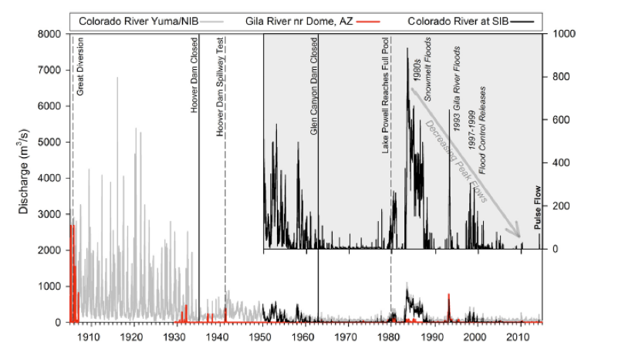

**Figure 1** – Peak discharges at various stages along the Lower Colorado River near the Colorado River Delta. Construction and subsequent reservoir filling of the Hoover (1930-1935) and Glen Canyon Dams (1964-1980) greatly reduced the amount of water reaching the Colorado River Delta, with no water reaching the Delta via the main channel in most years. Figure taken from Mueller *et al.* (2017).

The reductions in water flows to the Delta have altered geomorphological processes associated with sediment deposition. Whereas the Delta was previously sustained by hundreds of millions of tons of suspended sediment each year (Van Andel 1964), almost no sediment reaches the Delta now. Reductions in freshwater inputs have also affected the salinity of the Delta, which once had extensive areas of brackish water. Today, much of the Delta is considered a hypersaline inverse estuary, with salinity levels above the 35 ppt that is characteristic of typical seawater (Lavin and Sanchez 1999). This increase in salinity is also reflected in the Delta’s present-day bivalve community, which features a species assemblage more consistent with other fully marine environments in the Gulf of California (Dietl and Smith 2017).

**Importance of the Colorado River Delta**

The Colorado River Delta is located in an area that receives an average of less than 5 cm of annual precipitation. Thus, the landscape surrounding the Delta has minimal vegetation cover and little to no available surface water. This means that the surface waters and wetlands associated with the Delta, as well as its relatively complex vegetation structure, provide a crucial stopover for migratory birds (Hinojosa-Huerta *et al.* 2004). The Pacific flyway is a major migratory corridor along the west coast of North America and supports upwards of 350 species of birds annually. This includes two bird species that are federally listed under the Endangered Species Act in the United States (the Yuma clapper rail (*Rallus longirostris yumanensis*) and the southwestern willow flycatcher (*Empidonax traillii extimus*)) as well as numerous other species of conservation concern. Additionally, the Pacific flyway includes a large number of game birds such as ducks and geese that are relevant for hunters throughout the western U.S. Finally, it is worth noting that the relative importance of the Colorado River Delta—diminished in size though it may be—for migratory birds may increase in the coming decades as the Salton Sea, another major migratory bird stopover in the region, becomes increasingly saline and less suitable as habitat.

In addition to its importance for migratory birds, the Colorado River Delta also provides critical habitat for marine animals in the Gulf of California. Chief among these are the critically endangered totoaba (*Totoaba macdonaldi*) and the critically endangered vaquita porpoise (*Phocoena sinus*). The totoaba is the largest member of the drum family of fishes (Sciaenidae) and was once part of an abundant Gulf of California fishery. It spawns in the Colorado River Delta, and juveniles rely on brackish water of approximately 20 parts per thousand salinity for their development, a salinity level that is substantially lower than current conditions (Cisneros-Mata *et al.* 1995). The vaquita is considered to be the world’s most endangered marine mammal, with population estimates placing its numbers at perhaps just 30 remaining individuals (IUCN). The vaquita has an extremely small geographical range that is centered in the Colorado River Delta, and although vaquita bycatch from gillnet fishing is considered by far the biggest threat to its existence (D’agrosa *et al.* 2000), the diminished suitability of the Delta habitat may also be an important element of its decline.

Finally, the Colorado River Delta also helps to sustain major Gulf of California fisheries, which are based largely on catches of Gulf corvina (*Cynoscion othonopterus*) and a number of shrimp species. Both of these fisheries rely extensively on the Delta as nursery habitat, and declines in the catches of corvina and shrimp likely reflect both sustained overfishing and declining productivity of the Delta. Together, these fisheries contribute approximately $34 million annually to the economy of Baja California and Sinaloa, with most of the catch coming from small fishing operations (López-Sagástegui *et al.* 2016).

**Minute 319 and the Environmental Pulse Flow**

In 2012, International Boundary and Water Commission representatives from the United States and Mexico met to discuss water rights allocations to Mexico. The document that resulted, Minute 319, is primarily concerned with water rights allocations to Mexico. The Colorado River Compact allocates 1.5 million acre feet (AF) of Colorado River water to Mexico, nearly all of which is diverted by the Morelos Dam into agricultural irrigation canals that supply the Mexicali Valley. However, because the Morelos Dam is a diversion structure that does not impound water, Mexico has little control over how and when it water allocations are distributed. Furthermore, a 7.2 magnitude earthquake in Mexicali in 2010 severely damaged much of the region’s irrigation infrastructure, rendering Mexico’s supply of Colorado River water even more difficult to manage. Minute 319 allowed for Mexico to store some of its water rights allocations in Lake Mead, which last approached full pool in 2000 (USBR), while also establishing new benchmarks for Lake Mead levels and water delivered to Mexico. For example, if water level in Lake Mead exceeds 1,200 feet mean sea level (MSL), then Mexico’s annual allocation increases by 80,000 AF to 1,580,000 AF; conversely, if lake levels fall below 1,075 feet MSL, then Mexico’s allocation decreases by 333,000 AF to 1,167,000 AF. The United States also pledged $31 million to help improve Mexico’s damaged agricultural infrastructure and improve water delivery projects in the Mexicali Valley.

A secondary goal of Minute 319 was environmental restoration of the Colorado River below the Morelos Dam, including the Colorado River Delta. To this end, Minute 319 set aside approximately 150,000 AF of water for environmental flows, with about 100,000 of these to be released in a single pulsed flow from the Morelos Dam over a three week period. The remaining 50,000 AF were released more gradually as “base flows” from two irrigation canal spillways further downstream of the Morelos Dam. The scientists responsible for drafting the specifics of the environmental flow and implementing its release had both proximate and ultimate objectives. The ultimate objective was to demonstrate the efficacy of such an environmental release in order to secure future water allocations for other environmental flows. To this end, the proximate objectives were to **(1) Inundate the Colorado River floodplain (2) Stimulate recruitment of cottonwood and willow (3) Fortify existing native vegetation and (4) Increase riparian bird diversity and abundance** (Kendy *et al.* 2017).

Environmental releases were scheduled to occur in late spring to mimic natural high flows in the Colorado River and to coincide with natural periods of seed dispersal for riparian cottonwood and willow trees (Kendy *et al.* 2017). The primary pulse flow from the Morelos Dam commenced on March 23, 2014 and spilled an average of approximately 70 m3/s until April 14, 2014, with a peak release rate of about 130 m3/s during this time. The remaining releases, from the Kilometer 18 and Kilometer 27 spillways, occurred in April and May of 2014, with each releasing approximately 10 m3/s (Shafroth *et al.* 2017, Figure 2). Water released during the pulse flows eventually reached the Colorado River Delta on May 15, 2014, representing the first time since 1997 that the entire course of the Colorado River was connected to the Gulf of California.

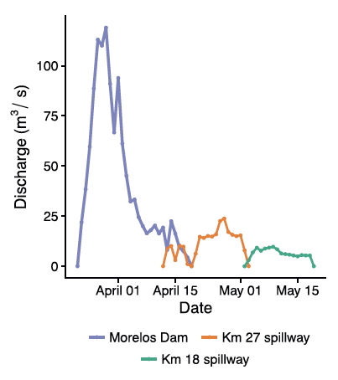

**Figure 2** – Magnitude and timing of 2014 environmental flow releases from the Morelos Dam and the Kilometer 27 and Kilometer 18 spillways. Figure taken from Shafroth et al. (2017).

**Effects of the Pulse Flow**

The first objective of the environmental pulse flow was to inundate the floodplain and to stimulate natural recruitment of cottonwood (*Populus fremontii*) and willow (*Salix gooddingi*). For the first part of this goal (floodplain inundation), the pulse flow did technically achieve its objective, and the entirety of the river course below the Morelos Dam was indeed inundated. However, over 90% of the main pulse of water released from the Morelos Dam ended up infiltrating dry sections of riverbed, where previous years without flows and groundwater pumping had led to drastic reductions in the height of the water table of up to 9 m (Ramirez-Hernandez *et al.* 2017). Only a small portion of the water allocated for the environmental flow actually reached the Delta, and much of this was water diverted into the Kilometer 27 and Kilometer 18 spillways. Researchers initially hoped that the magnitude of the primary pulse flow would be enough to lead to channel reworking and scouring of existing substrate and vegetation along the river course, although both of these goals were largely unmet (Mueller *et al.* 2017).

The second objective—stimulating recruitment of cottonwood and willow—had variable success that depended on the degree of active restoration and management involved. In one study, researchers monitored natural patterns of cottonwood and willow recruitment at various distances below the Morelos Dam (Shaforth *et al.* 2017). This study tracked each stage of plant recruitment, beginning with successful seed production by

mature plants, then monitoring dispersal of seeds, then measuring seed germination, and finally assessing successful establishment. Natural recruitment of both cottonwood and willow was limited in extent, with both only becoming established in river reaches within 15 km of the Morelos Dam (Figure 3).

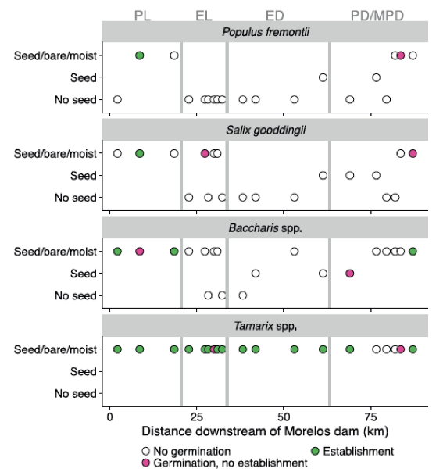

**Figure 3** – Patterns of natural establishment for three native and one non-native species of riparian vegetation at various reaches downstream of the Morelos Dam. The primary species of interest were cottonwood (*Populus fremontii*) and willow (*Salix gooddingii*), which only successfully established in areas within 15 km of the Morelos Dam. By contrast, non-native tamarisk (*Tamarix spp.*) became established at numerous locations along the river course. Establishment for all species only occurred when seed deposition coincided with bare soil and sustained soil moisture throughout the period of establishment.

Numerous factors contributed to the poor overall natural recruitment of cottonwood and willow. In some areas, pre-existing vegetation, including non-native species of tamarisk (*Tamarix spp.*) and reeds (*Phragmites australis*, *Arundo donax*) limited the availability of bare substrate and led to strong priority effects, whereby willow and germinants were competitively excluded. In lower reaches of the Delta, where bare substrate was plentiful and there was little competition, soil salinity precluded successful establishment of cottonwood and willow. In other areas approximately 25-60 km below the Morelos Dam—referred to as the ephemeral limitrophe and the ephemeral delta—a correlated set of issues hindered establishment. First, the lack of mature cottonwood and willow trees meant that few seeds were available to be dispersed during the pulse flow. Second, these same areas also had the highest rates of water recession after the main pulse flow event, which limited establishment of any seeds that did germinate. Shafroth *et al.* (2017) note that successful establishment of cottonwood and willow requires that the water table remain within 2 m of the soil surface during initial growth, a requirement that was only met in areas where mature vegetation was already established. In contrast to cottonwood and willow, which showed limited natural recruitment, non-native tamarisk appears to have benefited from the pulse flow, with numerous areas of establishment where cottonwood and willow failed to establish (Shafroth *et al.* 2017). This result likely reflects the much greater abundance of mature, seed-bearing tamarisk relative to cottonwood and willow at the onset of the pulse flow.

**Figure 4** – Map of the Colorado River south of the Northern International Boundary between Mexico and the United States. Areas of the river below the Southern International Boundary are generally considered to be a part of the Colorado River Delta. Taken from Shafroth *et al.* (2017)

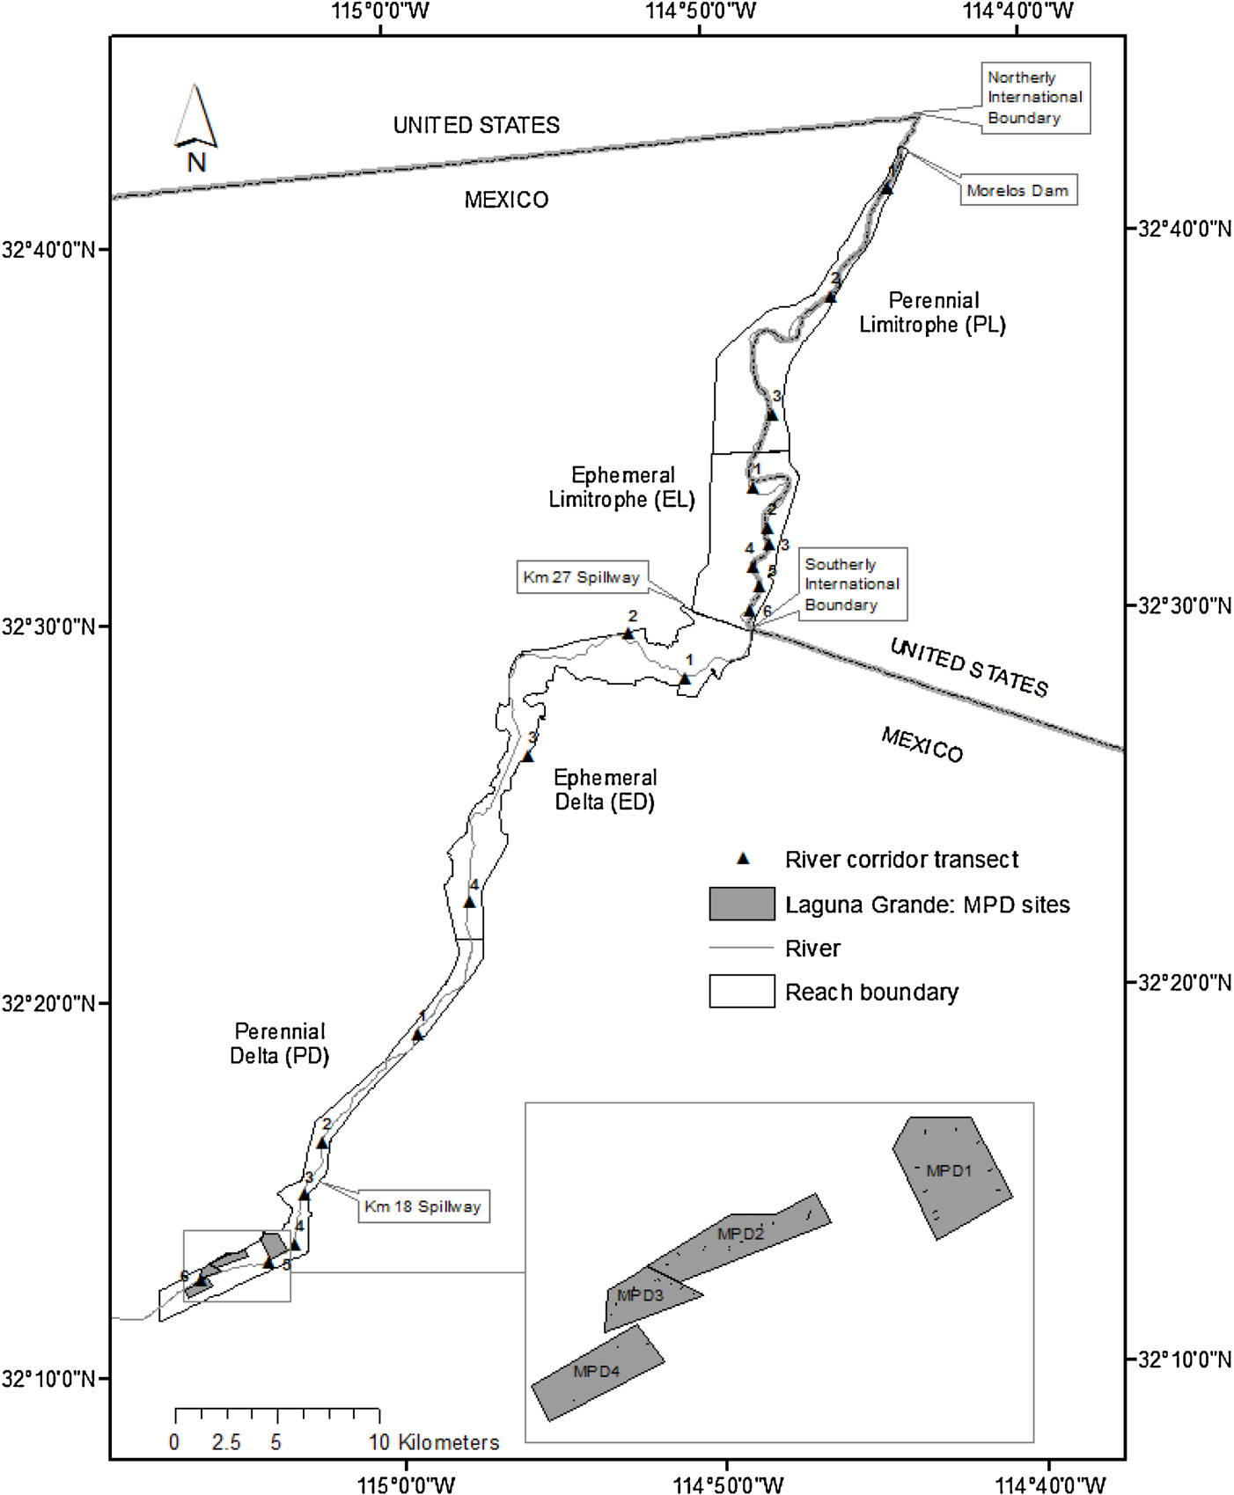

Although the success of natural cottonwood and willow establishment was limited, areas with more active restoration efforts saw somewhat greater success. Schlatter *et al.* (2017) monitored five sites along a 5 km stretch of river within the Delta, with each site exposed to four experimental treatments involving combinations of inundation, manual removal of tamarisk, and addition of cottonwood and willow seeds. They found that inundation was required for any establishment, with seedling establishment highest in areas that had non-native vegetation manually removed prior to water delivery. Seasonal timing was an important predictor of cottonwood and willow seedling establishment, with recruitment only occurring successfully in May, coincident with natural patterns of establishment. Even in areas where mature tamarisk was manually removed, the majority of recruitment in experimental plots was from naturally occurring tamarisk seed (Figure 5), suggesting that restoration efforts will need to be ongoing to ensure long-term success of cottonwood and willow. However, the authors do note that by the end of the study period, established cottonwood and willow plants were larger than tamarisk that established at the same time (Schlatter *et al.* 2017).

The third objective of the environmental pulse flow was to fortify existing native vegetation. This objective was assessed using normalized difference vegetation indices (NDVI) generated using satellite imagery. NDVI provides a rough proxy for landscape-scale greenness and primary productivity and was compared before the pulse flow, immediately after the pulse flow, and a year after the pulse flow to determine its effects on established vegetation. Jarchow *et al.* (2017) did indeed observe an increase in NDVI of about 15% between 2013 and 2014, and these increases remained even a year after the pulse flow had receded. While this “greening-up” response is ostensibly support for the stated objective, a substantial portion of the pre-existing vegetation along the river course was in fact non-native tamarisk, and river reaches that had tamarisk manually removed prior to the flow did not show increases in NDVI (Jarchow *et al.* 2017). Thus, without finer scale imagery that separately quantifies changes in NDVI for native and non-native vegetation, it is difficult to assess how successful this objective ultimately was.

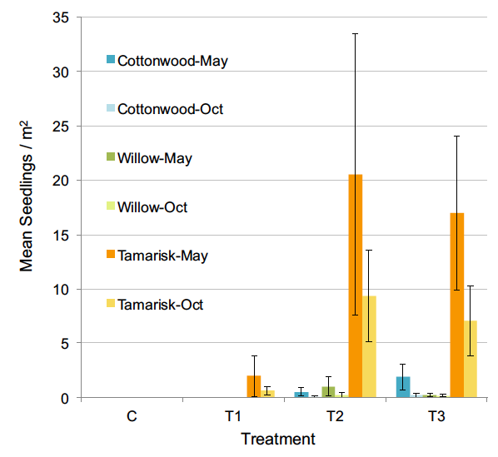

**Figure 5** – Seedling densities of cottonwood, willow, and tamarisk, averaged across five restoration sites. Treatments are as follows: C = control (no experimental manipulations), T1 = inundation only, T2 = inundation and mature tamarisk removal, T3 = inundation, tamarisk removal, and manual seed addition for cottonwood and willow. Taken from Schlatter *et al.* (2017).

The final objective of the environmental pulse flow was to increase riparian bird diversity and abundance. This objective was assessed by comparing pre-pulse flow bird surveys to post-flow surveys conducted a few months and a full year later. Nineteen bird species of special conservation concern were monitored and surveyed at various locations along the floodplain. Indeed, both bird abundance and diversity increased after the pulse flow, with effects that lasted beyond 2014. For the 19 species of primary concern, overall abundance increased by 49% between 2013 and 2014. The most pronounced increases in bird diversity and abundance were observed at sites where active restoration and cottonwood and willow planting took place, with these areas experiencing 50% greater bird abundance and 33% greater bird diversity than areas without active restoration (Minute 319 Interim Report, 2016). In addition, separate surveys of bird activity indicate that birds in the riparian corridor spent substantially more time foraging in willows after the pulse flow (Darrah *et al.* 2017). This was especially true for insectivorous birds such as Wilson’s warbler and suggests that new leaf growth associated with the pulse flow may have cascaded up to impact higher trophic levels, including birds (Darrah *et al.* 2017). Thus, overall, it seems that the objective of increasing riparian bird diversity and abundance was largely met. However, it is important to note that even in the absence of environmental flows, bird abundance and diversity may vary substantially from year to year within the Delta, so caution is needed before attributing observed increases entirely to the effects of the pulse flow.

**Recommendations for Future Environmental Flows**

The Minute 319 pulse flow was one of the largest releases of water for environmental purposes ever. As outlined by Kendy *et al.* (2017), the environmental objectives of the pulse flow were laid out explicitly, in part because past research had shown that restoration efforts are most successful when desired outcomes are specified beforehand. The specific objectives of the pulse flow were met to varying degrees.

For the first two objectives—floodplain inundation and cottonwood and willow establishment—future environmental water allocations should take advantage of the system of irrigation canals and spillways already in place to more efficiently move water to active restoration sites. In this way, flows can bypass areas where infiltration rates into the riverbed are high, thereby preventing water losses to areas where no mature cottonwood or willow trees are currently present and where restoration would require sustained flows from the Morelos Dam. Greater effort should also be made to manually remove tamarisk and other non-native vegetation over a larger areal extent, as this was shown to be the only successful way to promote cottonwood and willow establishment (Schlatter *et al.* 2017, Shafroth *et al.* 2017). For the third objective—fortifying existing native vegetation—future efforts should focus on mapping the pre-existing extent of native vegetation and then using finer-scale grid cells to monitor changes in NDVI associated with water releases. This will ensure that the landscape level changes in productivity can be isolated to areas that are indeed predominantly native vegetation, rather than tamarisk. Finally, for the third objective—increasing abundance and diversity of riparian birds—surveys should be conducted more frequently and over an extended period post-flow to obtain a better baseline for bird counts. Being able to conclusively attribute observed increases in bird abundance to environmental flows will require more than simply a correlative time series approach.

It is important to recognize that the magnitude of the 2014 release was miniscule—less than 3% of overall volume—compared to historic flows before dam construction along the Colorado River (Figure 6). In light of this fact, some of the results observed, such as the 49% increase in bird abundance between 2013 and 2014, are remarkable achievements. However, this also drives home the point that the Colorado River Delta is almost certainly never going to be restored to its former extent and sustained by anything even remotely approaching historical pre-dam flows. This highlights the need for careful planning, clearly stated objectives, active restoration, and regular reports on progress during future environmental flows. It also highlights the need for emphasis on realistic objectives. For example, while it would be desirable to restore salinity in the Colorado River Delta to levels that would promote growth of juvenile totoaba, this would almost certainly require unrealistic flows and would be a nearly impossible objective to meet. Instead, objectives should focus on active restoration and projects that can succeed even with limited environmental water allocations, especially in light of diminishing flows with the Colorado River Basin as a whole (Hanak *et al.* 2016).

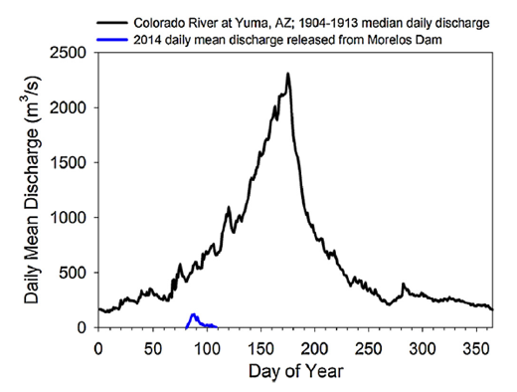

**Figure 6** – Daily mean discharge of the Colorado River at Yuma, AZ. The black line represents historical pre-dam flows, while the blue line shows the 2014 release from the Morelos Dam.

**The Future of Colorado River Delta Restoration**

River deltas around the world, including the Indus, Nile, and Yellow River, are threatened by upstream activities that impound water and sediment and alter natural biophysical processes. This problem is especially acute in arid areas, such as the southwestern U.S. While the Minute 319 pulse flow clearly was not implemented perfectly, it still represents a promising collaboration between policy makers, scientists, engineers, and farmers, and provides a useful starting point for future negotiations about environmental water releases. Encouragingly, Minute 319 was superseded by Minute 323 in 2017, which also includes provisions for environmental flows to the Delta and active monitoring through at least 2026. Thus, although the Colorado River Delta may never again resemble the place described by Aldo Leopold in 1922, it may still serve as a global model for collaborative and adaptive environmental management of limited freshwater resources.

**References**

**Cisneros-Mata MA, Montemayor-López G, Román-Rodríguez MJ** (1995) Life history and conservation of *Totoaba macdonaldi*. *Conservation Biology* 9: 806–814  
  
**D’agrosa C, Lennert-Cody CE, Vidal O** (2000) Vaquita bycatch in Mexico’s artisanal gillnet fisheries: Driving a small population to extinction. *Conservation Biology* 14: 1110– 1119. doi: 10.1046/j.1523-1739.2000.98191.x  
  
**Darrah AJ, Greeney HF, van Riper C** (2017) Importance of the 2014 Colorado River Delta pulse flow for migratory songbirds: Insights from foraging behavior. *Ecological Engineering* 106: 784–790. doi: 10.1016/j.ecoleng.2016.06.001  
  
**Dietl GP, Smith JA** (2017) Live-dead analysis reveals long-term response of the estuarine bivalve community to water diversions along the Colorado River. *Ecological Engineering* 106:749–756. doi: 10.1016/j.ecoleng.2016.09.013

**Hanak E, Gray B, Mount J et al.** (2016). California’s water: The Colorado River. Public Policy Institute of California. http://www.ppic.org/content/pubs/report/R_1016EHR.pdf  
   
**Hinojosa-Huerta O, DeStefano S, Carrillo-Guerrero Y, et al.** (2004) Waterbird communities and associated wetlands of the Colorado River delta, Mexico. *Studies in Avian Biology* 27: 52–60

**International Union for Conservation of Nature (IUCN)**. Assessment of gulf porpoise (*Phocoena sinus*). http://dx.doi.org/10.2305/IUCN.UK.2017- 2.RLTS.T17028A50370296.en  
  
**Jarchow CJ, Nagler PL, Glenn EP** (2017) Greenup and evapotranspiration following the Minute 319 pulse flow to Mexico: An analysis using Landsat 8 Normalized Difference Vegetation Index (NDVI) data. *Ecological Engineering* 106: 776–783. doi: 10.1016/j.ecoleng.2016.08.007  
  
**Kendy E, Flessa KW, Schlatter KJ, et al**. (2017) Leveraging environmental flows to reform water management policy: Lessons learned from the 2014 Colorado River Delta pulse flow. *Ecological Engineering* 106: 683–694. doi: 10.1016/j.ecoleng.2017.02.012  
  
**Lavı́n MF, Sánchez S** (1999) On how the Colorado River affected the hydrography of the upper Gulf of California. *Continental Shelf Research* 19: 1545–1560. doi: 10.1016/S0278-4343(99)00030-8

**Leopold A** (1949). The Green Lagoons – The Colorado River Delta. in *A Sand County Almanac: And Sketches Here and There.* Oxford University Press, Oxford, UK, pp. 150- 158.

**López-Sagástegui C, Mascareñas Osorio I, Jiménez Esquivel V, et al.** (2016) The value of fisheries in the Upper Gulf of California. DataMares Interactive Resource.

doi: 10.13022/M30P4S.

**Minute No. 319** (2012): Interim international cooperative measures in the Colorado River Basin through 2017 and extension of Minute 318 cooperative measures to address the continued effects of the April 2010 earthquake in the Mexicali Valley, Baja California. https://www.ibwc.gov/Files/Minutes/Minute_319.pdf

**Minute No. 319 Interim Report** (2016): Colorado River Limitrophe and Delta Envrionmental Flows Monitoring Interim Report.

https://www.ibwc.gov/Files/Minutes 319/2016_EFM_InterimReport_Min319.pdf

**Minute No. 323** (2017): Extension of cooperative measures and adoption of a binational water scarcity contingency plan in the Colorado River Basin.

https://www.ibwc.gov/Files/Minutes/Min323.pdf

**Mueller ER, Schmidt JC, Topping DJ, et al.** (2017) Geomorphic change and sediment transport during a small artificial flood in a transformed post-dam delta: The Colorado River Delta, United States and Mexico. *Ecological Engineering* 106: 757– 775. doi: 10.1016/j.ecoleng.2016.08.009  
  
**Pitt J** (2001) Can we restore the Colorado River delta? *Journal of Arid Environments* 49: 211–220. doi: 10.1006/jare.2001.0843  
  
**Ramírez-Hernández J, Rodríguez-Burgueño JE, Kendy E, et al**. (2017) Hydrological response to an environmental flood: Pulse flow 2014 on the Colorado River Delta. *Ecological Engineering* 106: 633–644. doi: 10.1016/j.ecoleng.2017.03.003  
  
**Schlatter KJ, Grabau MR, Shafroth PB, Zamora-Arroyo F** (2017) Integrating active restoration with environmental flows to improve native riparian tree establishment in the Colorado River Delta. *Ecological Engineering* 106: 661–674. doi: 10.1016/j.ecoleng.2017.02.015  
  
**Shafroth PB, Schlatter KJ, Gomez-Sapiens M, et al.** (2017) A large-scale environmental flow experiment for riparian restoration in the Colorado River Delta. *Ecological Engineering* 106: 645–660. doi: 10.1016/j.ecoleng.2017.02.016  
  
**Van Andel, TH** (1964) Recent marine sediments of the Gulf of California: *in* van Andel, T. H. and Shor, G. G., eds., *Marine Geology of the Gulf of California: American Association of Petroleum Geologists*. Memoir 3, Tulsa, Oklahoma, pp. 216-310.